TITLE UPPERCASE, CENTURY GOTHIC (CG) 14,
BOLD, JUSTIFY ALIGNMENT

Author^{1*}, Author², and Author³
¹Put your affiliation here complete, city, and country
²Put your affiliation here complete with city and country
³Put your affiliation here complete, city, and country
^{1*}e-mail, ²email, ³email
*email the Corresponding author

Article Info |  | ABSTRACT
Article history  Received …..  Revisied …..  Accepted ….. |  | Abstract (Use the following structured summary style with headings; not exceeding 250 words)  Background/purpose. [describe briefly the main problem addressed in the study; answer the question "Why was this research done?", and highlight the main purpose of the study]  Materials/methods. [provide a brief statement about the main methods in the research article]  Results. [summarize briefly the main findings of the study]  Conclusion. [indicate the main conclusion presented and verified in the study]
Keywords: Alphabetically sorted; Capitalized first word; From a to z; Maximum 5 keywords; Sentence case; Separate by semicolon (;) between keyword

- INTRODUCTION
Describes the problems studied along with a literature review (the theory does not need to make its own subtitle, but integrates it with the introduction), ended by explaining the purpose and necessity of the study. The six important points that must be included in the introduction should give a clear description of the following aspects (1) a brief general background of the study; (2) state of the art (a brief literature review) of previous study to justify the novelty of the article made (should refer to journals in the last 10 years); (3) gap analysis or gap statement (originality) or novelty statement or uniquely difference to the research compared to the previous study or based on state of the art (in terms of the importance of the research and comparison of uniqueness of the previous research); (4) problems and / or hypotheses (if any); (5) problem-solving approach (if any); (6) expected results or research objectives (CG 10pt font, justify, A left-aligned paragraph, 1.5 spacing, space between paragraphs 10pt).

- METHODS
Describe the methods/designs/procedures used in the study. Equipped with an exposure to the research site in general, and research subjects in detail. (CG 10pt font, justify, A left-aligned paragraph, 1.5 spacing, space between paragraphs 10pt).
  - Heading 2 If Required
Describe the methods/designs/procedures used in the study. Equipped with an exposure to the research site in general, and research subjects in detail. (CG 10pt font, justify, A left-aligned paragraph, 1.5 spacing, space between paragraphs 10pt).
  - Heading 3 If Required
Describe the methods/designs/procedures used in the study. Equipped with exposure to the research site in general, and detailed research subjects. (CG 10pt font, justify, A left-aligned paragraph, 1.5 spacing, space between paragraphs 10pt).

- RESULTS AND DISCUSSION

RESULTS (HEADING 1, UPPERCASE, FONT CG 10PT, BOLD)
Describe the results of the study in accordance with the problems formulated / reviewed in the introduction. Results and discussion are separated. All types of the research must discuss the findings based on theory. Four important points that must be implied/explicit in the results and discussion section are: (1) (what/how) the data presented has been processed (not raw data), set out in tables or pictures (select one), and give an information that is easy to understand and pictures/tables are clearly referenced; (2) (why) in the discussion section there is a connection between the results obtained and the basic concepts and/or hypotheses; (3) (what else) there is a match or contradiction with the results of other people's research; and (4) write the implications of the results of both theoretical and implementation of the research. (CG 10pt font, justify, A left-aligned paragraph, 1.5 spacing, space between paragraphs 10pt).
  - Heading 2 If Required
Describe the results of the study in accordance with the problems formulated/reviewed in the introduction. If you use Tables or Images, their numbers must be referred to in the presentation. Table 1 is an example of how to use Tables.
  - Heading 3 If Required
Describe the results of the study in accordance with the problems formulated/reviewed in the introduction. If you use Tables or Images, their numbers must be referred to in the presentation. Table 1 and Figure 1 are examples for how to use Tables and Figures.
Table 1. Table Caption Usage
The example of the question in Gutman scale | Yes | No
Question 1? | 90 | 10
Question 2? | 80 | 20
Question 3? | 70 | 30

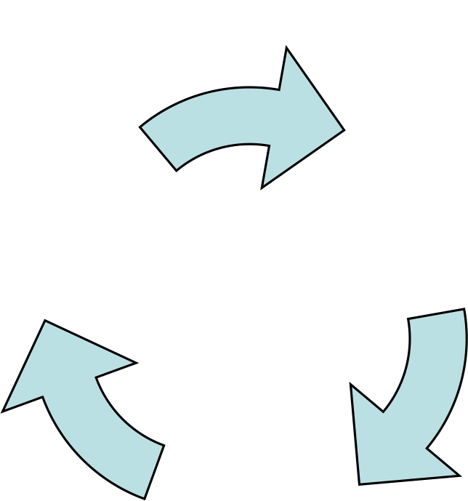

Figure 1. Picture of Caption Usage

DISCUSSION (HEADING 1, UPPERCASE, FONT CG 10PT, BOLD)
In the discussion section, there is a link between the results obtained and the basic concepts and/or hypotheses, and there is a match or conflict with the research results of other researchers. It can also be written the implications of the research results from both in theory and implementation.
- CONCLUSION
Describe the research conclusions according to the findings of the study. There is no need to quote in the conclusions (CG 10pt font, justify, A left-aligned paragraph, 1.5 spacing, space between paragraphs 10pt).
- ACKNOWLEDGEMENTS
If there is any (optional), give your acknowledgment here.
- REFERENCES
References contain all sources cited in the body of the article. The references are written based on the APA 6th style. Use the Mendeley application (free download) or Endnote (paid download), or another Reference Manager. References should not be less than 20 references, must contain more primary references, multiply reputable journals’ source. In justifying the originality or novelty, use the most updated reference of the last 10 years. (CG 10pt font, justify, A left-aligned paragraph, 1.5 spacing, space between paragraphs 10pt)

